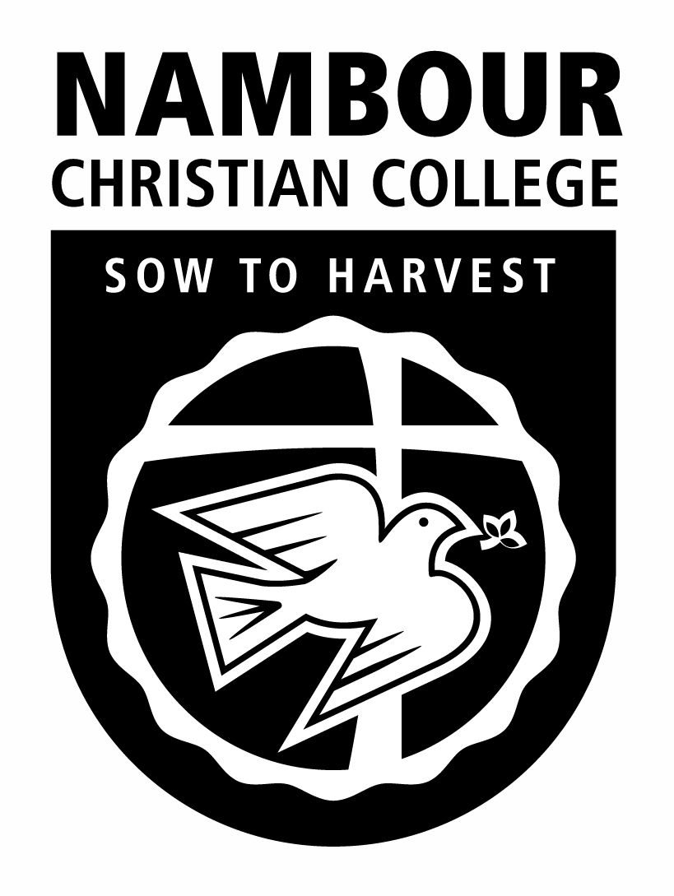
NAMBOUR CHRISTIAN COLLEGE
YEAR 11 HUMANITIES
Study of Religion – Semester 2, Term 4
Religion-State Relationships – Nationalism and Religion
Unit Outline

FOCUS: How does the influence of religion affect our ideas of what it means to belong to a modern nation-state?

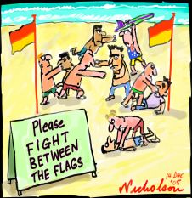
In today’s modern society it is important to understand how to be a global citizen. Students will investigate how one participates in a community of any size and the role religion plays within these communities. In particular, this unit will explore how communities interact with the world religions of Christianity, Judaism and Islam. Students are introduced to the idea of nationalism in general and how nationalism can act in a religious way through a short study of the breakdown of Yugoslavia. Beginning with a study of the interplay of religion and Australian identity, students then move to a study of Israel to investigate the relationship between religious belief and the Western State notion of ‘statehood’. Students will then turn their attention to the sectarian divide within Christianity between the Protestants and Catholics as they investigate the tensions that are manifested most violently through current and historical events in Northern Ireland. In each of these case-studies students will explore the nature and significance of religion as each have a profound impact on what it means to belong to a national and / or ethnic group. At the conclusion of the unit, students will complete a short response test exam. It is to be noted that this unit focuses exclusively on the interplay of nationalism and religion in the Western context. This is so that key concepts can be established for the religion-state relationships unit in Year 12 which begins to deal with statehood and religious freedom.
Fig 1. Nicholson on the Cronulla Riots, 2005, http://www.nicholsoncartoons.com.au/cartoon_4286.html

Weeks: 8 – 9

Enduring Understanding:

At the conclusion of the unit students will: be able to express their views on how religion shapes a sense of belonging and national identity in the modern world.

At the conclusion of the unit students will: | Levels of Bloom’s Taxonomy
- Identify how a nationalism and religion can function in a Western society | Knowledge / Remember
- Understand how religious belief can influence our understanding of ‘being Australian’ | Comprehension / Understand
- Demonstrate how religion can provide a rationale for contemporary expressions of nationalism | Application / Apply
- Compare and contrast how religion can cause division | Analysis / Analyse
- Compose a response to stimulus essay which investigates how religion can be manipulated to encourage or discourage the function of nationalism in modern societies | Synthesis / Design

EQUIPMENT NEEDED
- Textbook – Goldburg, P. et al (2008) Investigating Religion: Study of Religion for Senior Secondary Students, Cambridge University Press, Melbourne [avail. NCC Textbook Room]
- Student Handbook
- A4 journal notebook
- Appropriate stationery (pens, pencils, scissors, glue, ruler, coloured pencils, compass, protractor, etc)

NB. Your teacher will be observing and noting if you bring this equipment to class. A consistent habit of not bringing this equipment to class will be understood as you lacking organizational skills required to be a student in Year 12. Your teacher will ask you to attend the Responsible Thinking Classroom to develop an organizational plan to help you to develop these skills if you consistently do not bring this equipment and any other equipment requested by your teacher to class.

ASSESSMENT:

 | Type of Assessment | Conditions | Criteria assessed
Week 9 | Responses to stimulus: exam essay | - Response to unseen evidence, set question based around stimulus response items (Duration: 1 ½ hours)  - Stimulus materials: varied, issued one week prior  - Length: min. 600 words  - No notes allowed  - Clean copies of materials to be provided for test  - All materials must be relevant | C1; C2; C3

SKILLS TO BE DEVELOPED (common curriculum elements addressed in the course of the unit):

- Recognizing letters, words and other symbols
- Recalling/remembering
- Interpreting the meaning of words or other symbols
- Interpreting the meaning of pictures/illustrations
- Interpreting the meaning of tables or diagrams or maps or graphs
- Translating from one form to another
- Using correct spelling, punctuation, grammar
- Summarizing/condensing written text
- Compiling lists/statistics
- Recording/noting data
- Compiling results in a tabular form
- Approximating a numerical value
- Setting out / presenting / arranging / displaying
- Structuring/organizing extended written text
- Empathizing
- Comparing, contrasting
- Classifying
- Interrelating ideas/themes/issues
- Deducing
- Inferring
- Interpolating
- Extrapolating
- Applying strategies to trial and test ideas and procedures
- Applying a progression of steps to achieve the required answer
- Generalizing from information
- Hypothesizing
- Criticizing
- Analyzing
- Synthesizing
- Creating / composing / devising
- Justifying
- Judging/evaluating
- Perceiving patterns
- Visualizing
- Identifying shapes in two and three dimensions
- Searching and locating items / information
- Observing systematically
- Manipulating / operating / using equipment
- Sketching / drawing

RESOURCES (all call numbers refer to NCC Library)

Required reading (for teaching staff):

Heacox, D. (2002) Differentiating Instruction in the Regular Classroom: how to reach and teach all learners, grades 3-12, Free Spirit, Minneapolis [TR 371.39 HEA]

McGrath H & Noble T (2005) Eight Ways at Once. Pearson Education Australia: Sydney [TR 370 MCG]

Other resources (include relevant page numbers and NCC Library call numbers):

--------. (2006) Discovering Democracy: Australian Readers – Upper Secondary Collection, Curriculum Corporation, Melbourne [class sets]

Dixon, S & Greer, V (1998) Understanding the Modern World. Heinemann Education: Melbourne [TR 909 DIX]

Dorsey, J. (2010) ‘Palestine’s Heavy Metal Revolution’, EurekaStreet.com, April 19, 2010, http://www.eurekastreet.com.au/article.aspx?aeid=20573 [accessed April 20, 2010]

R Abdel-Fattah, ‘Living in a Material World’, Griffith Review#7 avail at: http://www.griffithreview.com/images/stories/edition_articles/ed7_pdfs/abdel-fattahed7.pdf

Greer, V. et al (1994) Understanding World History, Heinemann, Melbourne [909 GRE]

Greer, V. & Hospadaryk, J. (1995) Understanding World History: Teacher’s Resource Book, Heinemann, Melbourne [TR 907.12 GRE]

Heater, D. (1985) Our World Today, Oxford University Press, Melbourne [class sets]

Bauer, Y. (2001) ‘From Holocaust to the State of Israel’, Rethinking the Holocaust, Yale University Press, new Haven [avail Masterfile]

Beech, H. ‘Salvation Armies’, Time, April 26, 2010, pp. 32 – 36

Bickerton, IJ & Hill, M (2003) Contested Spaces: the Arab-Israeli Conflict, McGraw-Hill, Sydney [956.04 BIC]

Dalrymple, W ‘Modern India: an explosion of religion and faith’, The Australian Financial Review: Review, 12 February, 2010, pp. 6 -7 ; 9

Harney, C & Noble J (2008) Cambridge Studies of Religion: Stage 6, Cambridge University Press, Sydney [TR 200 HAR]

Dixon S & Greer V (1998) Understanding World history, Heinemann, Melbourne [909 GRE]

A range of news articles have been utilsed in the development of this unit:

Dorsey, J. (2010) ‘Palestine’s Heavy Metal Revolution’, EurekaStreet.com, April 19, 2010, http://www.eurekastreet.com.au/article.aspx?aeid=20573 [accessed April 20, 2010]

The Griffith Review, www.griffithreview.com
R Abdel-Fattah, ‘Living in a Material World’, Griffith Review#7 avail at: http://www.griffithreview.com/images/stories/edition_articles/ed7_pdfs/abdel-fattahed7.pdf
M Sayle, ‘God wills it! The bitter fruits of fundamentalism’, Griffith Review#7 avail at: http://www.griffithreview.com/edition7/106-essay/393-sayle7.html
T Morton, ‘Manufacturing ancient hatreds’, Griffith Review#7 avail at: http://www.griffithreview.com/edition7/107-reportage/388-morton7.html
M Amis, ‘The age of horroism’, Griffith Review#14 avail at: http://www.griffithreview.com/edition14/85-essay/184-amis14.html
L Kofman, ‘On becoming a Jew’, GriffithReview#15, avail at: http://www.griffithreview.com/edition15/84-memoir/172-kofman15.html

The Jerusalem Post, http://www.jpost.com/
Editorial, Jan 11, 2010
‘Israeli Jews oppose Swiss-style minaret ban’, Jan 11, 2010
‘No Licenses on Shabbath’, jan 12, 2010
L Derfner, ‘Survival instincts’, jan 15, 2010

Lyons, J, ‘Israelis unsettled as Elvis leaves building’, the Weekend Australian, May 22-23, 2010, p. 22

Required viewing or listening (include NCC Library call numbers as necessary):

Beyond Belief: the Orange Order, BBC podcast, July 6, 2009 [avail Masterfile]

One Nation Under God, VEA Education [DVD 227.3 ONE]

Matisyahu, ‘Jerusalem’, Youth, 2006 Sony BMG Music Entertainment, avail at: http://www.youtube.com/watch?v=3-C74ovvhwY

The following videos are available in the Clickview catalogue:

7:30 Report: The Rabbi and the Sheik
Beyond Beliefs
Compass: Family First – a federal crusade
Compass: Islam on Parade
Foreign Correspondent: Policeman’s beat in Belfast
Foreign Correspondent: Us and Them
Halal Mate
In the Name of the Father

Judah and Mohammed
Live and Become
Salam Cafe
Serbs last Stand (Dateline 1998)
Shadya
The Beach (use with discretion)
The Middle East: roadmap or roadblock to peace
Waking the Dead 10-9-10
Who do you think you are: David Tennant

Suggested Weekly Breakdown (this is subject to change according to individual class needs):

Enduring Understanding: Students will be able to express their views on how religion shapes a sense of belonging and national identity in the modern world.
Week Number | Suggested development of unit | Assessment Piece
1 / 2 | Identify how a nationalism and religion can function in a Western society  KQ: What is nationalism and how can it interact with religion?  - Students read and answer questions in Dixon & Greer, ‘The meaning of nationalism’, Understanding the Modern World, pp. 153 – 154  - avail: T:\Teachers\Humanities\Senior Studies of Religion\Unit Outlines and Resources\Year 11\Term 4 Sem 2 - Religion-State Rships Nationalism Religion\DixonGreerUnderstandingModernWorld\AnIntroNationalism.pdf  - Students PMI the approach to the integration of nationalism and religion that is reflected in the hymn ‘I Vow to Thee My Country’  - Avail: T:\Teachers\Humanities\Senior Studies of Religion\Unit Outlines and Resources\Year 11\Term 4 Sem 2 - Religion-State Rships Nationalism Religion\I Vow to Thee My Country.pptx  - Extension Q’n: Prince Charles recently floated the idea that he when crowned King of England he should be called the ‘Defender of the Faiths’ rather than ‘Defender of the (English Christian) Faith’ – PMI this suggestion.  - Students view Serbs Last Stand (Dateline 1998) [CV: search term – serb] – how is nationalism used in a ‘religious’ sense?  - Q’ns and background information in Dixon & Greer, ‘The Collapse of Yugoslavia’, Understanding the Modern World, pp. 163 – 168  - avail at: T:\Teachers\Humanities\Senior Studies of Religion\Unit Outlines and Resources\Year 11\Term 4 Sem 2 - Religion-State Rships Nationalism Religion\DixonGreerUnderstandingModernWorld\The Collaps of Yugoslavia.pdf  - Background work on Kosovo conflict at:  - View Waking the Dead 10/9/10 [cv: search – waking dead] NB. This is a fictional story using a ‘CSI-style’ premise investigating a death that occurs during the genocide of the Yugoslav civil war in the 1990s. This episode can be very confronting – it is recommended that a teacher preview it before screening to their class.  KQ: Where can relationships between religion and state are seen around the world?  - Students read Goldberg, Investigating Religion, p. 4 and complete Activity 1.1 & 1.2  - Rd ‘6.1 Religion and Politics’ in Heater Our World Today, p. 78 – 79 T:\Teachers\Humanities\Senior Studies of Religion\Unit Outlines and Resources\Year 11\Term 4 Sem 2 - Religion-State Rships Nationalism Religion\D HeaterPoliticalPwrReligion OurWorld2day.pdf  - Students read:  - H Beech, ‘Salvation Armies’, Time April 26, 2010 T:\Teachers\Humanities\Senior Studies of Religion\Unit Outlines and Resources\Year 11\Term 4 Sem 2 - Religion-State Rships Nationalism Religion\H Beech SalvationArmies.pdf  - W Dalrymple, ‘Modern India: an explosion of religion and faith’, Australian Financial Review, Feb 12, 2010 T:\Teachers\Humanities\Senior Studies of Religion\Unit Outlines and Resources\Year 11\Term 4 Sem 2 - Religion-State Rships Nationalism Religion\FinReview WDalrymple Mod India Feb 12 2010.pdf  - Students watch evening news broadcasts for one week and note the religion-state relationships that are reported
2 / 3 | Understand how religious belief can influence our understanding of ‘being Australian’  KQ: What is the religious demographic breakdown in Australian society?  - Students use data for Activity 7.36 & 7.37 in Goldburg, Investigating Religion, pp. 178 – 180  - Instructions to draw a pie graph are located at T:\Teachers\Humanities\Senior Studies of Religion\Unit Outlines and Resources\Year 11\Term 4 Sem 2 - Religion-State Rships Nationalism Religion\How to Draw a Pie Graph by Hand.docx  KQ: How does religion influence the cultural discourse in Australia?  - Students view ‘7:30 Report: The Rabbi and the Sheik’ avail: T:\Teachers\Humanities\Video Files\SOR\The Rabbi and the Sheik 730Report261010.wmv  - Students complete work on the idea of the beach as being central to Australian identity and how this shapes our response to the Cronulla Riots:  - ‘Between the Flags’, SOSE Magazine 1/2007 [TR 910.7 STU]  - Worksheets avail: T:\Teachers\Humanities\Senior Studies of Religion\Unit Outlines and Resources\Year 11\Term 4 Sem 2 - Religion-State Rships Nationalism Religion\SOSEMag1-2007  - DVD: The Beach [CV: search term – the beach] [DVD 994.08 BEA] or on CV: search term - beach  - Students compare and contrast how Australian citizens use religious ideals to influence Australian culture and society  - Students will need to view both the following videos (could be done for H/W through the Schoolbag option) on CV prior to completing a Venn diagram exercise to prior to writing a paragraph response:  - Compass: Family First – a federal crusade [CV: search term – family first]  - Islam on Parade [CV: search term – islam parade]  KQ: What are the issues that are similar between ‘people of faith’ Australians and how do these effect our view of ‘being Australian’  - Students complete an Extent Barometer exercise on the issue ‘To what extent should the values and beliefs of non-Christians be taken into consideration when formulating new laws in Australia?’ – PwrPt (including a link to report on Cronulla Riots at: T:\Teachers\Humanities\Senior Studies of Religion\Unit Outlines and Resources\Year 11\Term 4 Sem 2 - Religion-State Rships Nationalism Religion\To be a citizen in Australia is.pptx  - Jigsaw exercise: Students independently view an episode of Salam Cafe or Halal Mate (avail on CV) and identify the issues that face a Muslim living in Australian society today [there are a number of episodes available (5); it would be good to distribute the viewing of all episodes amongst the class evenly  - View DVD: Beyond Beliefs [in Teacher Resource kit: TR 291 OHA – also avail in CV: search term – muslims]  - Students add to extent barometer creations based on what they have learned through the video exercises  - Read R Abdel-Fattah, ‘Living in a Material World’, Griffith Review#7 avail at: http://www.griffithreview.com/images/stories/edition_articles/ed7_pdfs/abdel-fattahed7.pdf
4 / 6 | Demonstrate how religion can provide a rationale for contemporary expressions of nationalism  The United States: KQ: What does it mean to be ‘One Nation Under God’?  - Students view DVD One Nation Under God [DVD227.3 ONE]  - Students explore article and online graphs and video by C Grossman, ‘Americans views of God shape attitudes on key issues’, http://www.usatoday.com/news/religion/2010-10-07-1Agod07_CV_N.htm?csp=usat.me  - Students use this information to provide a concept map investigating whether the United States is ‘One Nation Under God’  - See http://www.graphic.org/concept.html for guidance on various forms of concept maps  Israel: KQ: Is Israel ‘a Jewish State’ or a ‘state for Jews’?  - Students view film Live and Become [CV: search term – Israel]  - Students read ‘Israel’ in Goldburg, Investigating Religion, pp. 6 – 7  - Complete Act 1.6, p. 7  - View The Middle East: roadmap or roadblock to peace [CV: search term – middle east Israel]  - Complete worksheet avail at: T:\Teachers\Humanities\Senior Studies of Religion\Unit Outlines and Resources\Year 11\Term 4 Semester 2 - Religion-State Relationships - Religious Freedom and the State\Middle East Roadmap or Roadblock worksheet.docx  - Complete worksheet ‘Israel and the Palestinians’ in Greer et al, Understanding World History, avail: T:\Teachers\Humanities\Senior Studies of Religion\Unit Outlines and Resources\Year 11\Term 4 Sem 2 - Religion-State Rships Nationalism Religion\Dixon Greer Israel Understand Mod World.pdf  - Students view Judah and Mohammed or Shadya [CV: search term – Judah or shadya] – J & M follows the lives of two 15 yr old boys growing up in contemporary Israel; Shadya follows the life of a 16 yr old Israeli Arab Muslim girl who fights for the Israeli Tae Kwon Doe national team  - Students understand the origins of the Zionist perspective:  - Students complete exercises from Bickerton, Contested Spaces T:\Teachers\Humanities\Senior Studies of Religion\Unit Outlines and Resources\Year 11\Term 4 Sem 2 - Religion-State Rships Nationalism Religion\Bickerton Zionist docs.pdf  - Matisyahu , ‘Jerusalem’ http://www.youtube.com/watch?v=3-C74ovvhwY – lyrics at: T:\Teachers\Humanities\Senior Studies of Religion\Unit Outlines and Resources\Year 11\Term 4 Sem 2 - Religion-State Rships Nationalism Religion\Jerusalem lyrics by Matisyahu.docx  - Students read various media articles on the role of religion in the modern state of Israel and assess the validity of the Zionist perspective  - J Lyons, ‘Israelis unsettled as Elvis leaves building’, The Australian, May 22 – 23 http://www.theaustralian.com.au/news/world/israelis-unsettled-as-elvis-leaves-building/story-e6frg6so-1225869769976  - Dora McPhee (VIC) responds to Lyons’ “Israelis unsettled as Elvis Costello leaves the building”, The Australian, 22May10 May 22, 2010  - T McGirk, ‘Jerusalem divided’, Time, Dec 3 2007: T:\Teachers\Humanities\Senior Studies of Religion\Unit Outlines and Resources\Year 11\Term 4 Sem 2 - Religion-State Rships Nationalism Religion\Jerusalem Divided Time magazine.pdf  - Various articles from the Jerusalem Post avail: T:\Teachers\Humanities\Senior Studies of Religion\Unit Outlines and Resources\Year 11\Term 4 Sem 2 - Religion-State Rships Nationalism Religion\Jerusalem Post Misc Articles  - ‘Students read Y Bauer ‘From Holocaust to the State of Israel’ – where does Bauer differ from the Zionist perspective?  KQ: what does protest music tell you about the situation in Israel and the Palestinian territories?  - Students read the article ‘Palestine’s heavy metal revolution’, EurekaStreet.com, April 19, 2010 avail at: http://www.eurekastreet.com.au/article.aspx?aeid=20573  - A range of articles can also be used to reflect on the Arab-Palestinian issue:  - Griffith Review (www.griffithreview.com ), for example:  - M. Sayle, ‘God wills it! The bitter fruits of fundamentalism’, The Lure of Fundamentalism #7  - T. Morton, ‘Manufacturing ancient hatreds’, The Lure of Fundamentalism #7  - M. Amis, ‘The age of horrorism’, The Trouble with Paradise #14  New Internationalist, (www.newint.org)  - J. Robertson, ’40 years is enough’, May 2007  - S. Jabr, ‘Occupation and the mind’, May 2007  - O. Barghouti, ‘Boycott Israel’, May 2007
7 / 8 | Compare and contrast how religion can cause division  KQ: What was the source of the Troubles in Northern Ireland  - Students KWHL the SBS news report on violence surrounding the Orange Order Marches in July, 2009 – avail: T:\Teachers\Humanities\Video Files\SOR\SBS World News Orange Order Marches Jul 2009.wmv  - Students listen to podcast Beyond Belief: the Orange Order 6 July 09 avail Masterfile or at: T:\Teachers\Humanities\Senior Studies of Religion\Unit Outlines and Resources\Year 11\Term 4 Sem 2 - Religion-State Rships Nationalism Religion\BBC OrangeOrder Belief_ 06 JUL 09.mp3  - Read & Answer relevant questions in ‘6.2 Christianity’ & ‘6.3 Northern Ireland’ in Heater, Our World Today, pp. 80 – 84 avail at: T:\Teachers\Humanities\Senior Studies of Religion\Unit Outlines and Resources\Year 11\Term 4 Sem 2 - Religion-State Rships Nationalism Religion\D Heater N Ireland Our World Today.pdf  - Read and Answer Greer, Understanding Modern World, T:\Teachers\Humanities\Senior Studies of Religion\Unit Outlines and Resources\Year 11\Term 4 Sem 2 - Religion-State Rships Nationalism Religion\DixonGreerUnderstandingModernWorld\Ireland  - Students view Who do you think you are: David Tennant [CV: search term – david tenant]  - Read and answer relevant questions in ‘6.10 The Conflict in Northern Ireland’ in Greer et al, Understanding World History, pp. 176 – 177 & complete crossword, p. 98 in Teacher Resource Book T:\Teachers\Humanities\Senior Studies of Religion\Unit Outlines and Resources\Year 11\Term 4 Sem 2 - Religion-State Rships Nationalism Religion\Greer Conflict in N Ireland UndWorld History.pdf  KQ: How effective is the citizen’s voice expressed in the religious societies of Ireland  - Jigsaw exercise: students compare and contrast life in Belfast during and after the Troubles by viewing Foreign Correspondent episodes in CV:  - Policeman’s beat in Belfast  - Us and Them  - Students compare and contrast the performance of ‘Sunday Bloody Sunday’ by U2 from the DVD Rattle and Hum to any of the other voices expressed in the Foreign Correspondent episodes: T:\Teachers\Humanities\Video Files\SOR\U2 - Sunday Bloody Sunday with subtitles.wmv  - Students PMI the assessment of this performance in Conspiracy of Hope: T:\Teachers\Humanities\Senior Studies of Religion\Unit Outlines and Resources\Year 11\Term 4 Sem 2 - Religion-State Rships Nationalism Religion\U2 - SundayBloodySunday Conspiracy of Hope.docx  - Students view In the Name of the Father [CV: search term – name father]
9 | Compose a response to stimulus essay which investigates how religion can be manipulated to encourage or discourage the function of nationalism in modern societies.  Students Complete Response to Short Response to Stimulus Test | Response to Stimulus Essay (600- 800 words)

